UNIT 4 – CLOUD SECURITY ASSIGNMENT
Name: Suyash Bhanage
PRN:2124UCSM1026
Title
Launch a Windows Virtual Machine on AWS EC2 and Connect Using Remote Desktop Protocol (RDP)
1. Abstract
This assignment demonstrates how to deploy a Windows Server virtual machine using Amazon EC2 and securely access it through Remote Desktop Protocol (RDP). A security group is configured to permit RDP access only from the user's public IP address. After connecting, system information is inspected, a local user account is created, Windows Firewall is enabled and verified, and a text file is created to confirm basic server functionality.
2. Aim
To launch a Windows Server instance on AWS EC2, configure secure RDP access, and perform basic Windows administration tasks.
3. Objectives
- Launch a Windows Server virtual machine on AWS EC2.
- Configure a security group for restricted RDP access.
- Connect to the server using RDP.
- Inspect Windows Server system information.
- Create a local user with a strong password.
- Enable and verify Windows Firewall.
- Create and verify a text file on the server.
- Document the configuration and results using screenshots.
4. Tools and Technologies
- Amazon Web Services (AWS)
- Amazon EC2
- Windows Server
- Remote Desktop Protocol (RDP)
- Windows PowerShell
- Windows Defender Firewall
5. Procedure
Step 1: Launch the EC2 Instance
I opened the AWS EC2 console and launched a Windows Server instance. I selected a suitable instance type, created a key pair, configured the network settings, and launched the instance. I waited for the instance to enter the Running state and for its status checks to pass.
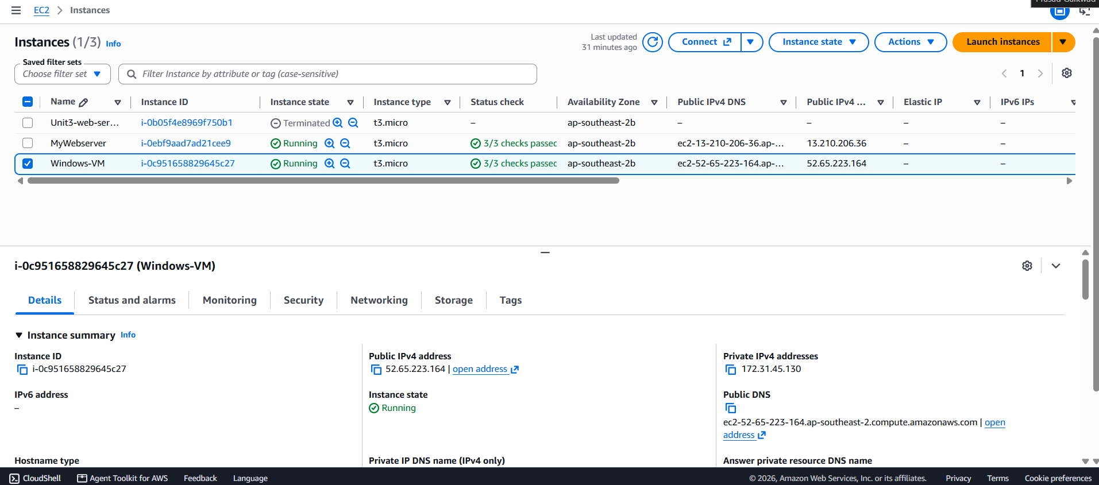
Step 2: Configure the Security Group
I created a security group named Windows-RDP-SG. I configured an inbound rule using TCP port 3389 and restricted the source to my public IP address. This reduced exposure by preventing unrestricted RDP access from the internet.
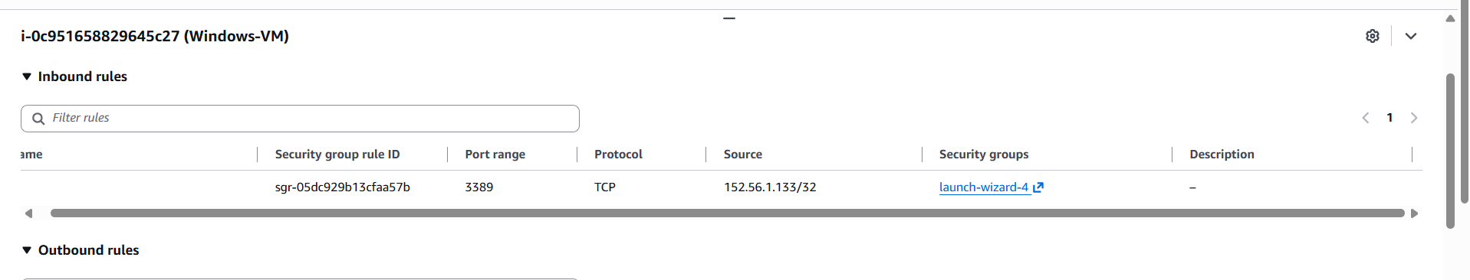
Step 3: Connect Using RDP
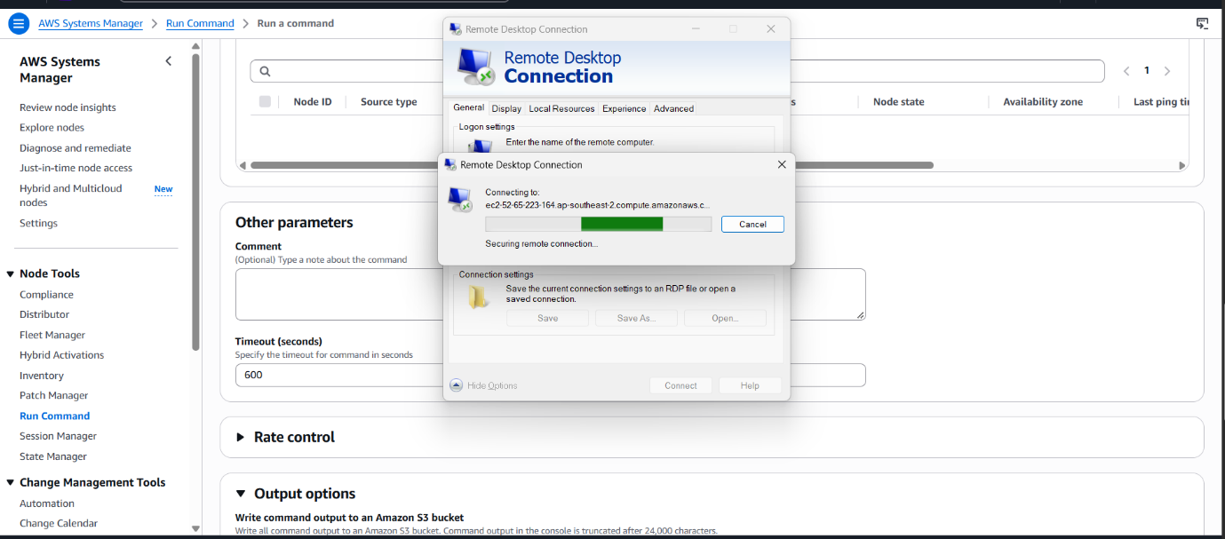
I retrieved the Windows administrator password using the EC2 key pair and connected from my Windows computer using Remote Desktop Connection (mstsc). After successful authentication, the Windows Server desktop was displayed.

Step 4: Inspect System Information
I used PowerShell to view the operating system and hardware details.
Get-ComputerInfo | Select-Object CsName, WindowsProductName, WindowsVersion, OsArchitecture
Get-CimInstance Win32_ComputerSystem |
Select-Object Manufacturer, Model, TotalPhysicalMemory, NumberOfProcessors
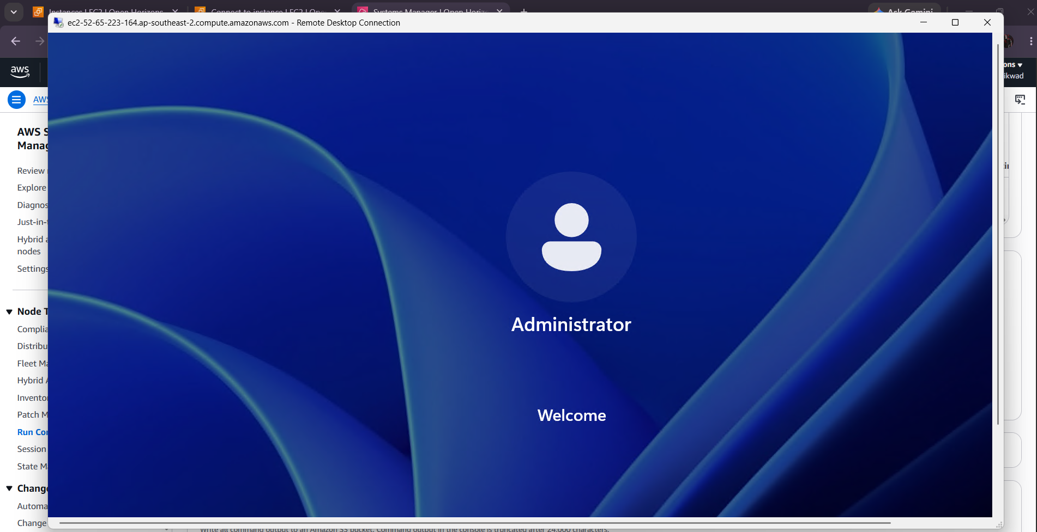

Step 5: Create a Local User
I created a local user account named LabUser and assigned a strong password using PowerShell. I verified that the account was created successfully.
$Password = Read-Host "Enter a strong password" -AsSecureString
New-LocalUser -Name "LabUser" -Password $Password
Get-LocalUser -Name "LabUser"
Step 6: Enable Windows Firewall
I enabled Windows Firewall for the Domain, Private, and Public profiles and verified the configuration.
Set-NetFirewallProfile -Profile Domain,Private,Public -Enabled True
Get-NetFirewallProfile | Select-Object Name, Enabled
Screenshot: Insert the firewall status output.
Step 7: Create and Verify a Text File
I created a file named CloudSecurityLab.txt on the Windows Server desktop and added a short message. I then used PowerShell to verify its contents.
Set-Content -Path "$env:USERPROFILE\Desktop\CloudSecurityLab.txt" `
-Value "Windows Server deployed on AWS EC2 for Unit 4 Cloud Security."

Get-Content "$env:USERPROFILE\Desktop\CloudSecurityLab.txt"
6. Security Configurations
- RDP was restricted to the user's public IP address.
- The EC2 key pair was kept private.
- A strong password was assigned to the local user.
- Windows Firewall was enabled for all profiles.
- The new local user was not granted unnecessary administrator privileges.
- Passwords and private keys were excluded from screenshots and documentation.
7. Results
The Windows Server EC2 instance was launched and accessed through RDP. System information was inspected, a local user account was created, Windows Firewall status was checked, and a text file was created and verified.
Complete this section only after confirming each result in your own AWS environment.
8. Conclusion
This assignment provided practical experience in deploying a Windows virtual machine on AWS EC2 and performing basic server administration. It demonstrated the importance of restricting RDP access, protecting key pairs and passwords, managing local user accounts, and enabling Windows Firewall.
9. References
- AWS EC2 Documentation: https://docs.aws.amazon.com/AWSEC2/latest/UserGuide/EC2_GetStarted.html
- AWS RDP Connection Guide: https://docs.aws.amazon.com/AWSEC2/latest/UserGuide/connect-rdp.html
- AWS Windows Instance Troubleshooting: https://docs.aws.amazon.com/AWSEC2/latest/UserGuide/troubleshoot-connect-windows-instance.html

